Assignment 3

**1.** Create a bucket in IBM object storage.  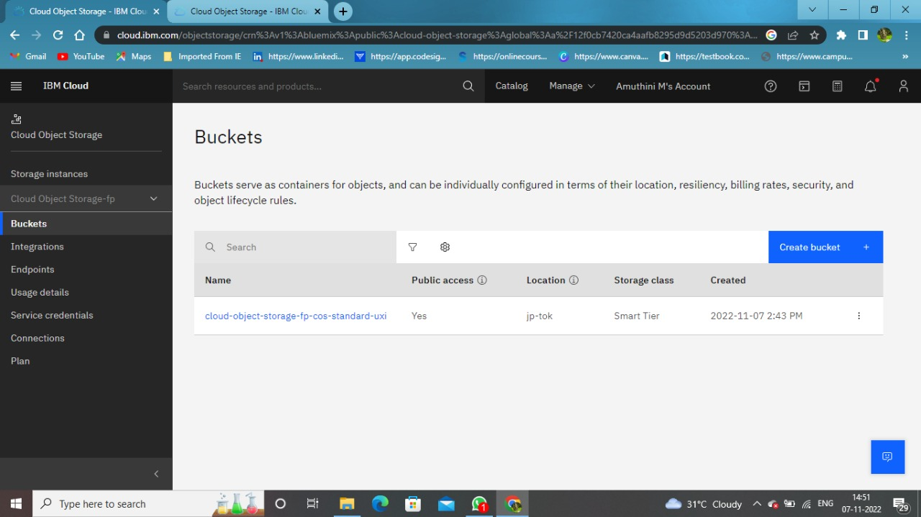

1. Upload any 5 images to IBM object storage and make it public. Write HTML code to display all the 5 images

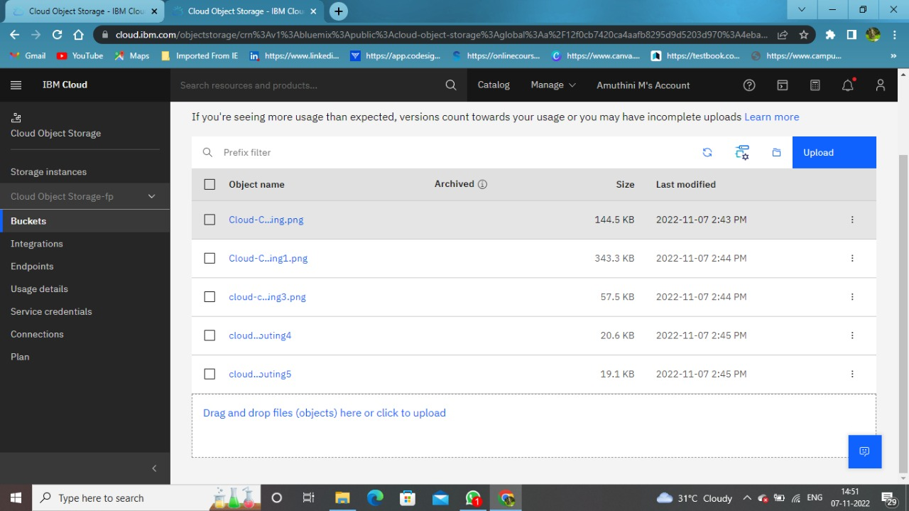

HTML Code to display the images in IBM Object Storage  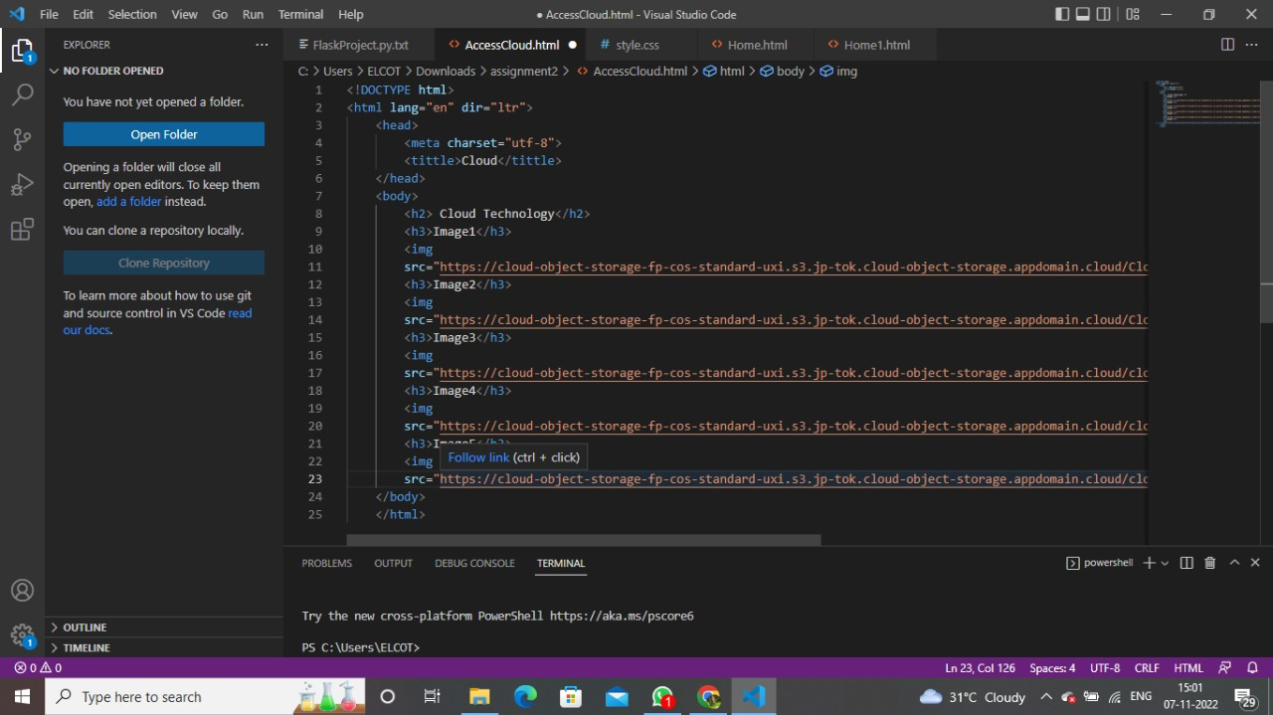

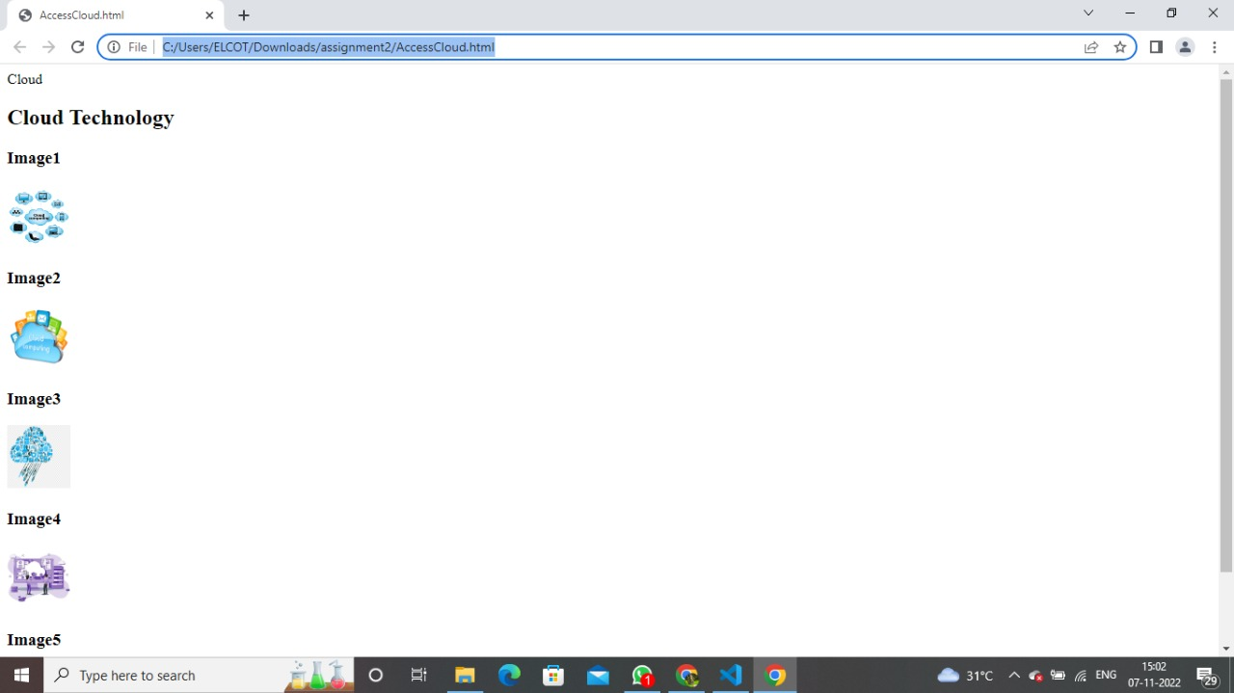

1. Upload a CSS page to the object storage and use the same page in your HTML code.  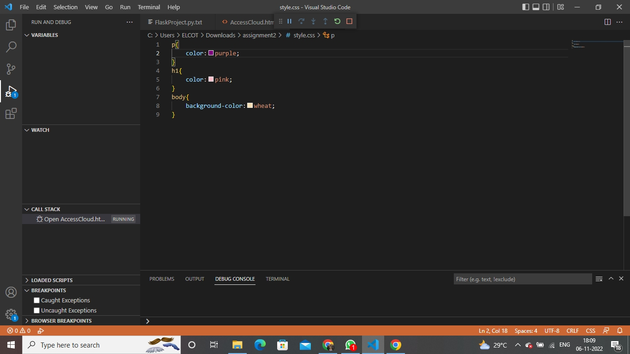

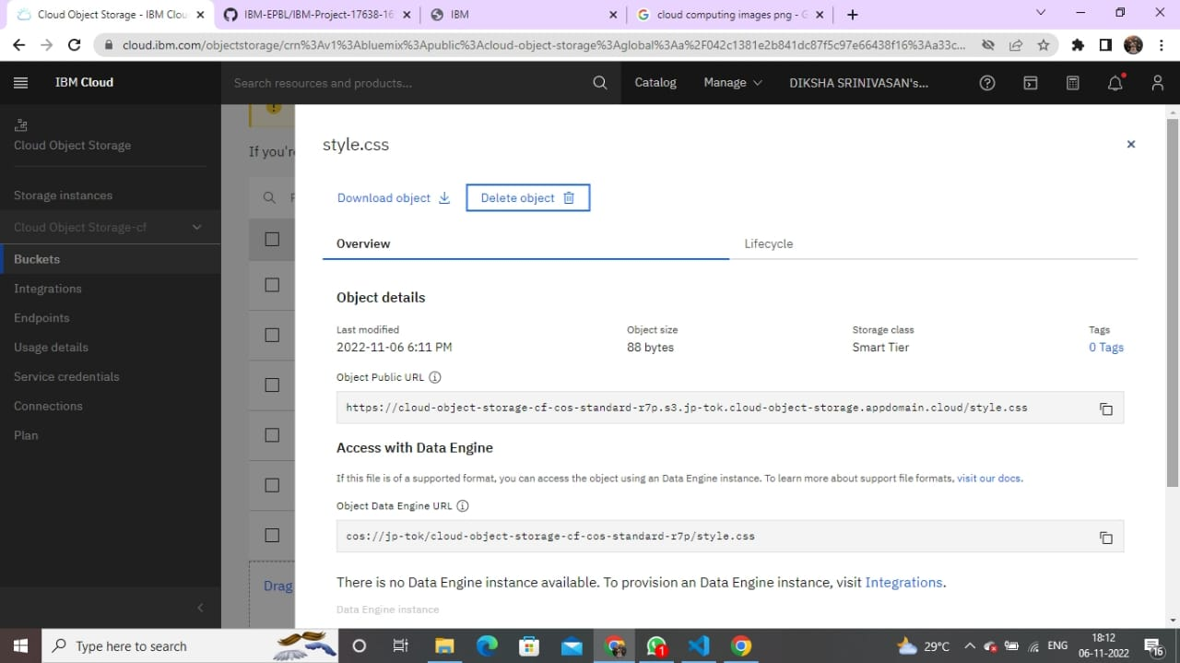

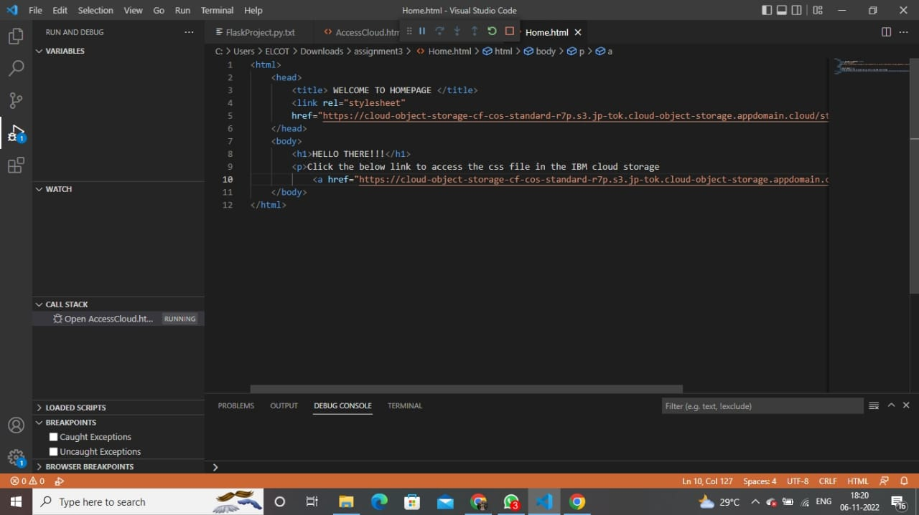

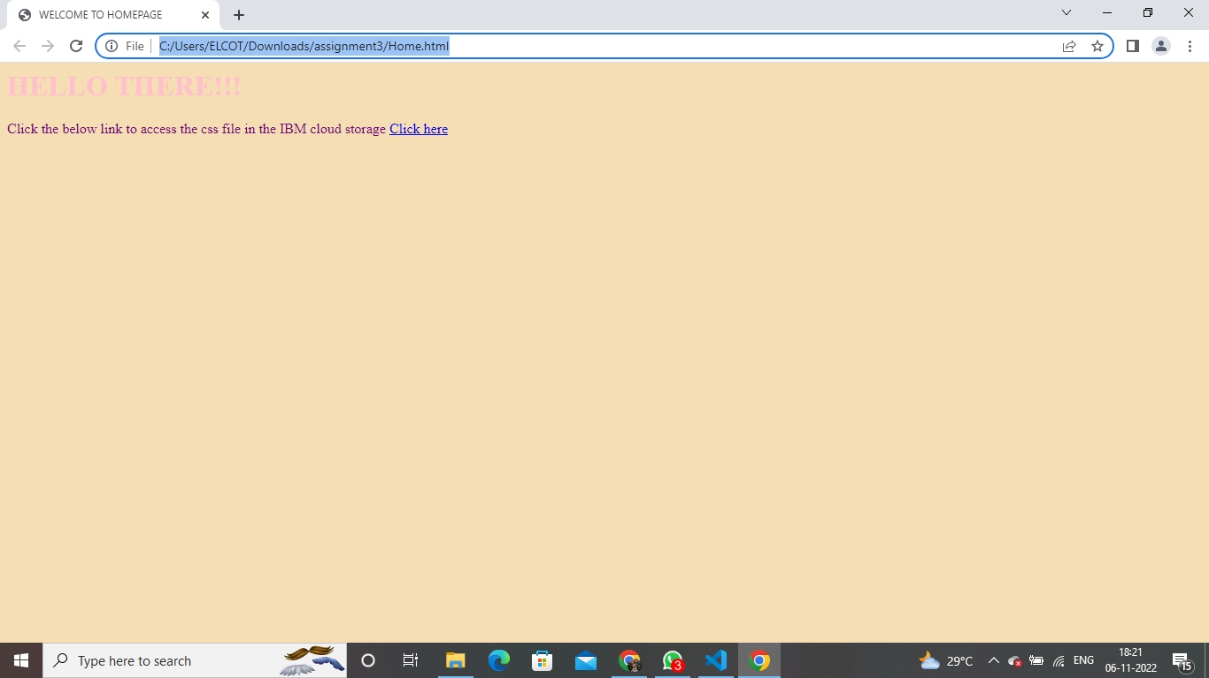

1. Design a chatbot using IBM Watson assistant for hospital. Ex: User comes with query to know the branches for that hospital in your city. Submit the web URL of that chat bot as an assignment.

URL: [https://web-](https://web-chat.global.assistant.watson.appdomain.cloud/preview.html?backgroundImageURL=https%3A%2F%2Fus-south.assistant.watson.cloud.ibm.com%2Fpublic%2Fimages%2Fupx-dde9d74b-de24-4965-80ff-ff7eba112f2c%3A%3A95ffdf79-0a93-4256-8f1e-23ef15ee514a&integrationID=b0e11007-92a0-446d-bc27-77fb60af6152&region=us-south&serviceInstanceID=dde9d74b-de24-4965-80ff-ff7eba112f2c)

[chat.global.assistant.watson.appdomain.cloud/preview.html?backgroundImageURL=https %3A%2F%2Fus-south.assistant.watson.cloud.ibm.com%2Fpublic%2Fimages%2Fupxdde9d74b-de24-4965-80ff-ff7eba112f2c%3A%3A95ffdf79-0a93-4256-8f1e23ef15ee514a&integrationID=b0e11007-92a0-446d-bc27-77fb60af6152&region=ussouth&serviceInstanceID=dde9d74b-de24-4965-80ff-ff7eba112f2c](https://web-chat.global.assistant.watson.appdomain.cloud/preview.html?backgroundImageURL=https%3A%2F%2Fus-south.assistant.watson.cloud.ibm.com%2Fpublic%2Fimages%2Fupx-dde9d74b-de24-4965-80ff-ff7eba112f2c%3A%3A95ffdf79-0a93-4256-8f1e-23ef15ee514a&integrationID=b0e11007-92a0-446d-bc27-77fb60af6152&region=us-south&serviceInstanceID=dde9d74b-de24-4965-80ff-ff7eba112f2c)

--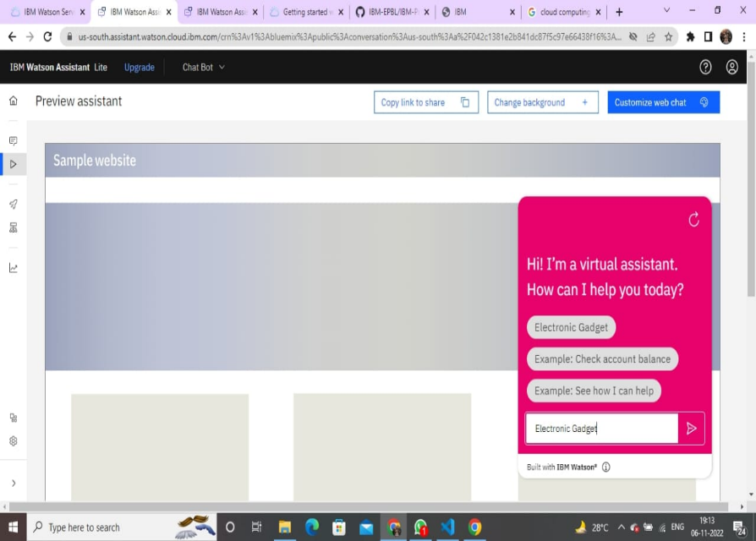

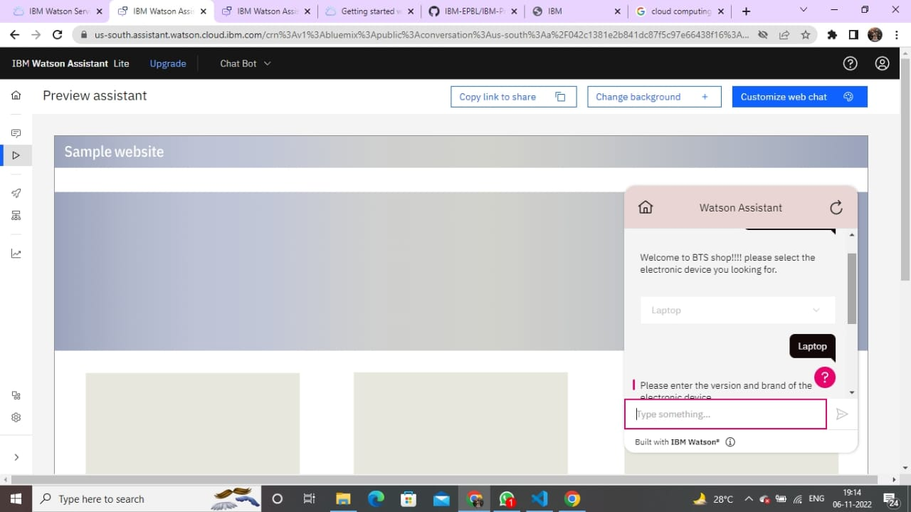

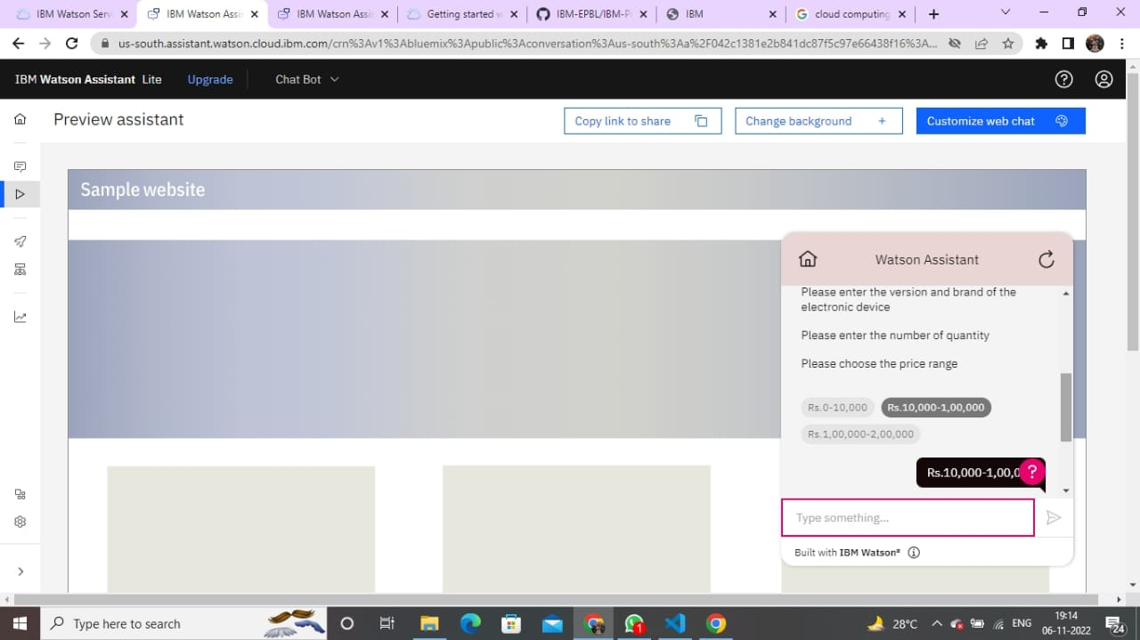

1. Create Watson assistant service with 10 steps and use 3 conditions in it. Load that script in HTML page.

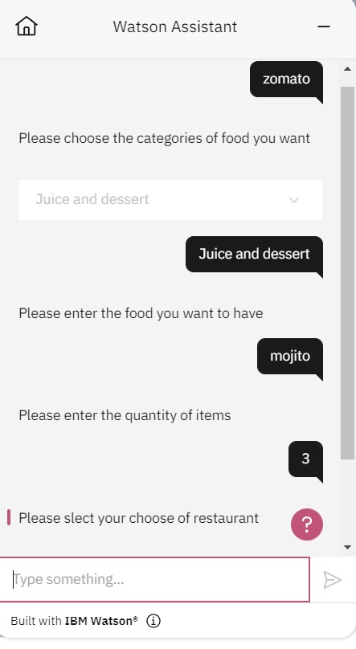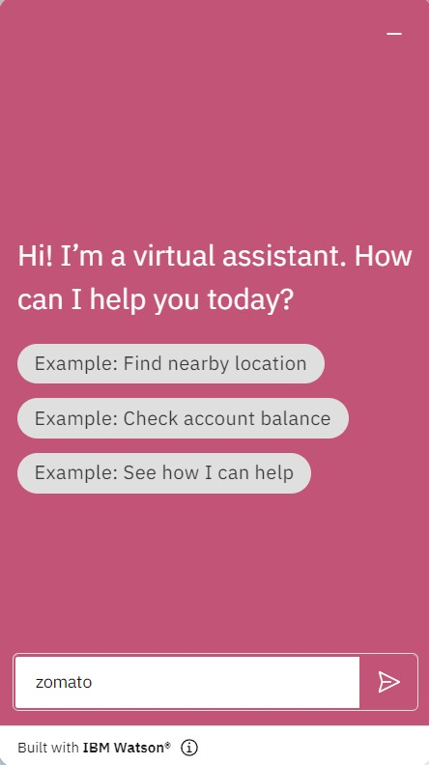

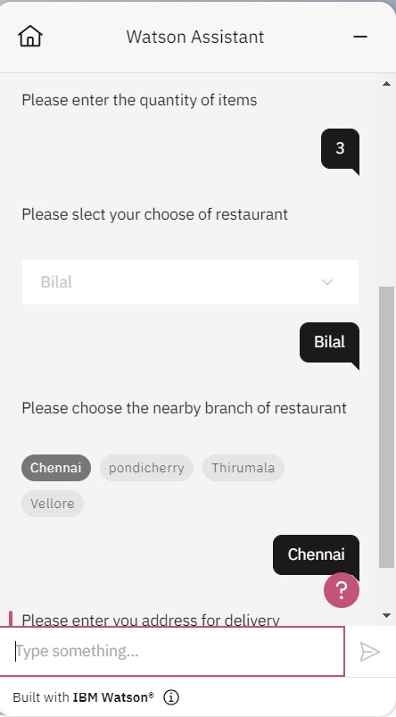 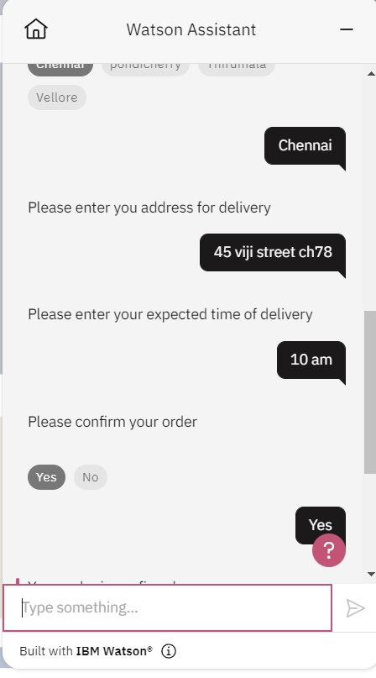

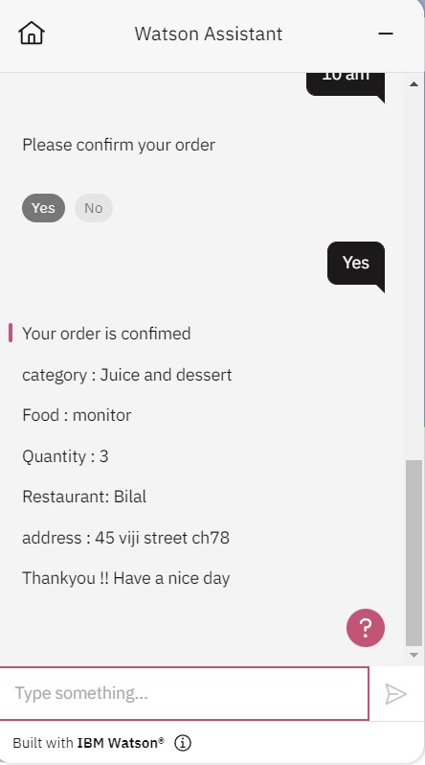

Script in HTML page:

